**DAILY ONLINE ACTIVITIES SUMMARY**

|  |  |  |  |  |  |  |  |  |
| --- | --- | --- | --- | --- | --- | --- | --- | --- |
| **Date:** | **27/05/2020** | | | | | **Name:** | **Hanan Saleem Baji** | |
| **Sem & Sec** | **4th SEM 'A' Section** | | | | | **USN:** | **4AL18CS024** | |
| **Online Test Summary** | | | | | | | | |
| **Subject** | | **Object Oriented Concepts** | | | | | | |
| **Max. Marks** | | **30** | | **Score** | | | **26** | |
| **Certification Course Summary** | | | | | | | | |
| **Course** | **1.Java Programming** | | | | | | | |
| **Certificate Provider** | | | **1. Great Learning Academy** | | **Duration** | | | **1. 2 hour** |
| **Coding Challenges** | | | | | | | | |
| **Problem Statement:** 1. Write a C Program to sort an array of integers in ascending order and display the sorted array and Number of passes performed for sorting. | | | | | | | | |
| **Status: completed** | | | | | | | | |
| **Uploaded the report in Github** | | | | | **Yes** | | | |
| **If yes Repository name** | | | | | <https://github.com/saleemhananbaji/C-coding> | | | |
| **Uploaded the report in slack** | | | | | **Yes** | | | |

ONLINE TEST DETAILS: Online test was conducted on the fifth module of **Object Oriented Concepts**. Test contains 30 questions of 1 Mark each. I have scored 26 Marks.

Snapshot:

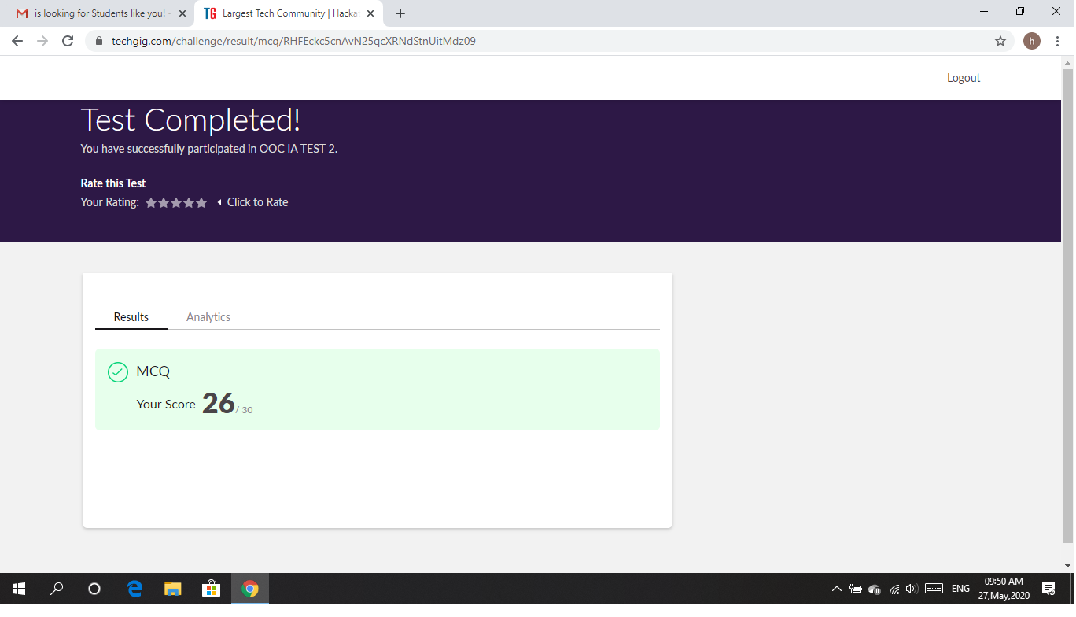

Certification Course Details: As the continuation of Java Programming certification course, I was able complete Arrays and Functions in Java.

Snapshot:

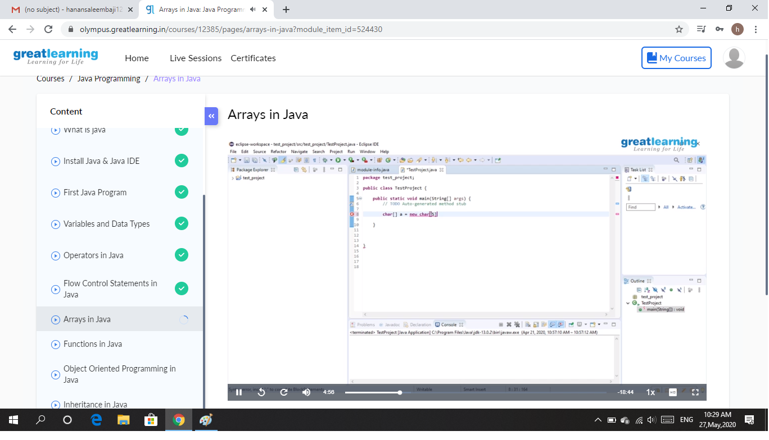

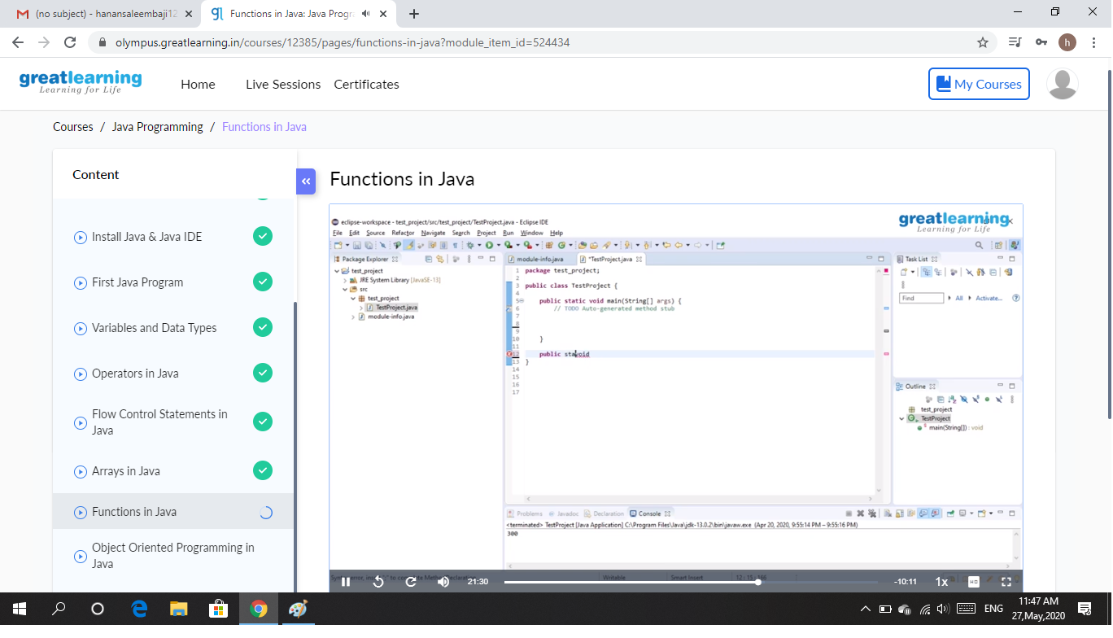

CODING CHALLENGES DETAILS: Problem statements

1. In Bubble sort, each pass consists of comparison each element in the file with its successor (i.e. x[i] with x[i+1]) and interchanging two elements if they are not in the proper order. The array may be sorted in any pass. If the array is sorted, then remaining passes should be skipped off. Write a C Program to sort an array of integers in ascending order and display the sorted array and Number of passes performed for sorting.

Solution : Uploaded it in github

Snapshot:

